# Stealth Chunky Sneakers

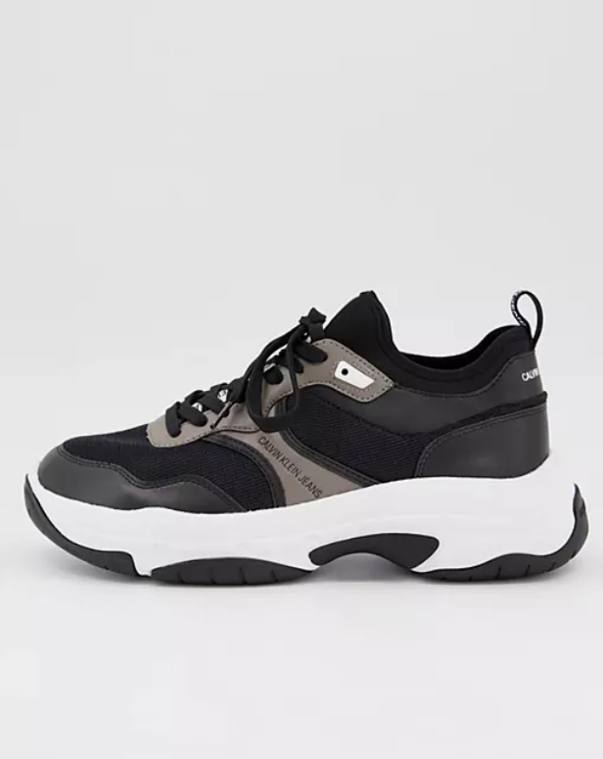Details:

Color Combination: The CK Stealth Chunky Sneakers boast a sleek and stylish color scheme featuring charcoal black, taupe grey, and deep midnight blue.

Material: Constructed from high-quality synthetic leather and breathable textile materials, ensuring durability and comfort.

Sole: Equipped with a chunky rubber sole in a contrasting color for a bold and modern aesthetic.

Closure: Secure lace-up closure system for a customized and snug fit.

Branding: Subtly embossed CK logo detailing on the tongue and side panel adds a touch of designer flair.

Comfort: Padded collar and cushioned insole provide exceptional comfort and support, making them ideal for all-day wear.

Style: The CK Stealth Chunky Sneakers exude a sense of urban sophistication, making them a versatile choice for both casual and semi-formal occasions.

Occasion: Perfect for urban adventures, city strolls, or adding a contemporary edge to everyday attire.

Versatility: Pair with jeans, chinos, or even tailored trousers for a fashion-forward look that's sure to turn heads.